**Name:** Unsha Aftab

**CMS ID:** 217673

**Assignment:** 01

**Subject:** Advanced Programming

**Project choosen:** Wordpress

**Configuration:**

I chose WordPress to study as Open source software. This is because I am currently running two blogging websites, i.e., Techacker.net and reviewsgarage.com on an online platform such as siteground and godaddy for the past 8 months. But, for this particular project assessment, I am shifting my online hosting to local hosting.

For the configuration phase, I downloaded the wordpress files. I connected it to database via xampp application. For that purpose, I used htdocs folder to put my files into it. I followed steps and by filling necessary information, I installed wordpress. After this step, I logged in to wordpress dashboard by filling in necessary credentials.

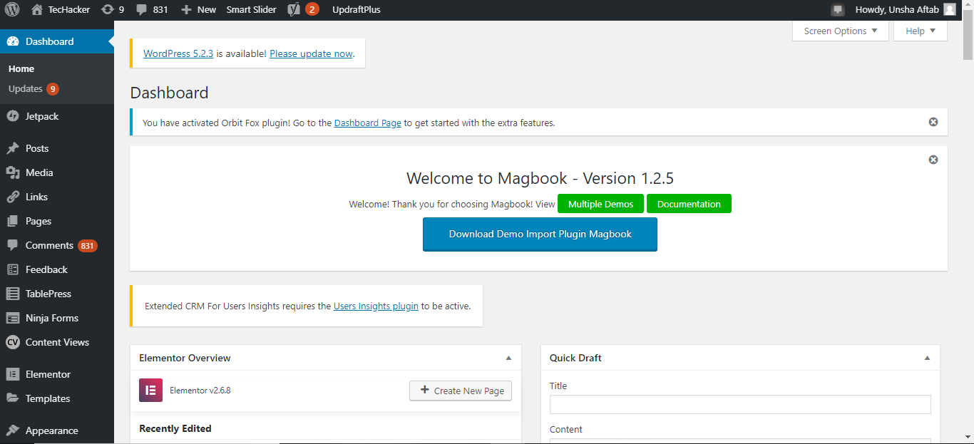

**User perspective:**

As a wordpress user, especially in case of Techacker.net, you can do following tasks:

1. You can add the plugin to search directly via this search menu.

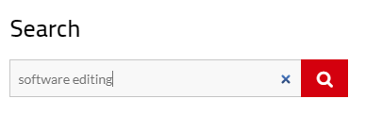

1. You can add a comment using this textarea:

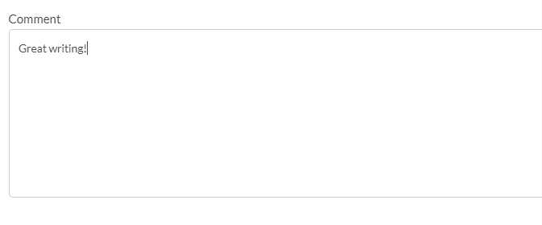

1. The theme is used enable user to update them about the new articles:

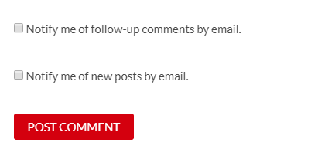

Moreover, you can get notifications about new comments and new posts via email platform.

1. You can follow the website content on different social media platforms:



1. You can directly visit the website homepage using this click only options.

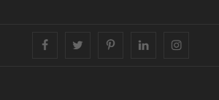

1. This website techacker.net offers you the opportunity to get to Amazon page directly. The website is amazon affiliated. It takes you to the amazon page directly.



1. You can subscribe the website and you will get notifications about the new contents every time.

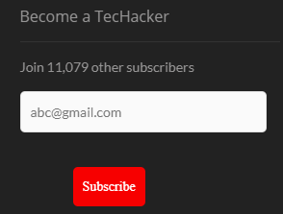

**Being Database developer**

I studied the database of the website. As it is blogging website, I came to know of following entities taking part to form a complete website. It is a blogger, article, Comments, Advertisement, Social media platform and the users. Although there are more than these entities, but I drew possible ERD noticing these entities.

The ERD is draw below:

Article

Writer

Writes

Comments on

Advertisement

follows

User

Social Media

**Coder view:**

The WordPress folder contains 3 folders in addition:

1. Wp-content
2. Wp-admin
3. Wp-includes

Each of the folder contains more detailed folders and files.

1. Wp-content:

This directory contains WordPress user-supplied content. All the plugins are stored in this directory in wp-content/plugin folder. Moreover, we can get to know about theme the WordPress is using in this directory in wp-content/theme folder.

1. Wp-admin:

This directory connect WordPress to the database. All the admin files are stored here. It displays dashboard of the WordPress. Moreover, the additional category you create in your website is stored in this directory. Similiarly, you can get the complete advance options to configure your website in this folder.

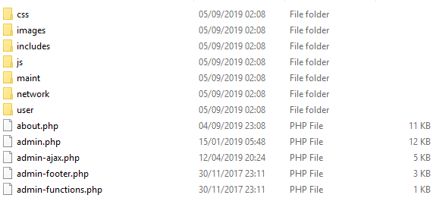

Although the directory contains many files and folder, but the admin.php is the core of this folder. Every important functioning and important features such as connecting to the database and loading of the dashboard is controlled by this file. It also promptly checks for the administrative permissions granted to the user.

Other important files are displayed below:

1. User.php:

Used for the user administration control panel.

1. Network.php:

Allows multi-site functioning.

1. Update.php:

Updates the website about the added content.

1. Wp-include:

This folder contains many other files that provide important functioning to the wordpress. It contains JS files and rest-api files. You can find many files but I will discuss functions.php here:

The functions.php acts like a wordpress plugin. You can add a plugin that works like a pre-defined function or a model. The only difference in this file and the one found inside the wp-content is that your function only works till theme remains active.

**Plugins used:**

I installed **“Google Analytics Dashboard for WP (GADWP)” plugin from the side option “plugin” in the dashboard. However, the file automatically got pasted inside wp-content/plugin folder. Using this small module, I can easily see the google analytics in the dashboard portion:**

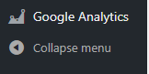

**Learning:**

1. I came to know about much advanced features of wordpress. I was using it for blogging but could not formally customize it myself. Thus, I learned many new things from it.
2. I learned how to install wordpress and connect to database. I learned the primary features and the configuration process.
3. I learned how to study the open source software. I explored the files and their core functionalities respectively.
4. I gained the basic knowledge of how an OSS works.